Contents

Integrated assignments 14

Source material 27

Glossary 70

Integrated assignments

Introduction

There are two integrated assignments supporting these materials:

- Risk assessment
- Customer service.

These provide learners with an opportunity to extend and apply the skills they have developed within their vocational course and through the use of these materials. They are structured in a similar style to Key Skills assignments, but the content reflects learning from particular modules.

Introducing the assignments

Teachers should go through the assignments with learners to check that they understand the tasks and have strategies for tackling each one. Learners can be asked to produce an action plan or checklist, to ensure that they are clear about the demands of each task within the assignment. Learners should be made aware of the signposting to the relevant modules within the Embedded Learning materials if they need to look back and check some skills.

Assessing learners

Learners are expected to complete tasks independently with the minimum of teacher input. The marking scheme identifies the units and elements of the National Occupational Standards, Key Skills and the Adult Core Curricula for Literacy and Numeracy.
Learners’ performance can be assessed on all three aspects of the task or one specific area. Coverage of the National Occupational Standards includes some performance criteria and/or underpinning knowledge from the NVQ. Additional questioning or observation of tasks may provide sufficient evidence for learner portfolios.
Integrated assignment 1
Risk assessment

Health and safety is very important in the workplace. Your employer is responsible for providing a safe working environment. You are also responsible for your own health and safety and the health and safety of others. This includes your workmates, customers and other members of the public.

In this assignment you can show your knowledge of health and safety issues within your own work area. You will need to complete Parts A–D.

- Complete a risk assessment for a job at work.

- Research two hazards and safe methods of work.

- Describe an accident using an Accident report form.

- Make a list of people who would be involved in investigating an accident.

PART A

- Think about a job or task that you may be asked to do at work. Write a brief description.

- Use the risk assessment table on the next page to list any risks or hazards related to this task. These may be risks that apply to your work role in general or risks that are related just to this task.
Think about:
If you have any problems with this task you can look at the health and safety information in the embedded paper-based materials Module 1: The working environment.
  - the people involved
  - the materials or equipment being used
  - the work area.

- Complete the risk assessment table on the next page to show what action you think should be taken to ensure safe working, and identify who is responsible for this action.
Risk assessment table
Task description:
Hazard or risk | Methods or actions to ensure safe working | Person responsible

PART B

Find out as much as you can about two of the hazards you have identified and the methods you can use to protect people.

Make sure you have included the following:

  - what the hazard is
  - how it affects people in your workplace
  - methods you can take to avoid accidents
  - actions to take if an accident happens.

Present your findings using graphics.
Sources of information and evidence you can use
  - Workplace policies and procedures
  - Leaflets or booklets from the Health and Safety Executive (HSE)
  - the Internet, e.g. http://www.hse.org.uk/
  - Photographs with explanations
  - Drawings or plans of the work area
  - Examples of safety signs and symbols that relate to this work area
  - A colleague or supervisor
Photocopy and highlight anything that relates to the hazards you have identified.
If you have any problems with this task you can look at the health and safety information in the embedded paper-based materials Module 1: The working environment.
Note
You may want to add more information to the Risk assessment table in Part A after you have completed your research.
PART C

Think again about the safe working methods for this job.

What might happen if these are not used? Discuss this with your teacher or with a partner.

Think about a possible accident that may occur. Use this information to complete an Accident report form. (Use the Accident report form from the Source material or download a form from the RIDDOR website www.riddor.gov.uk.)
If you have any problems with either of these tasks you can look at the embedded paper-based materials Module 1: The working environment.
Before you start to complete the Accident report form, you may
find it useful to make notes using the headings from the form.

PART D

Make a list of all the people who would be involved in reporting and investigation an accident in your workplace.

Make sure you find out what each person is responsible for.
Explain this to a colleague or your teacher.
If you have any roblems with this task, talk to your health and safety representative.
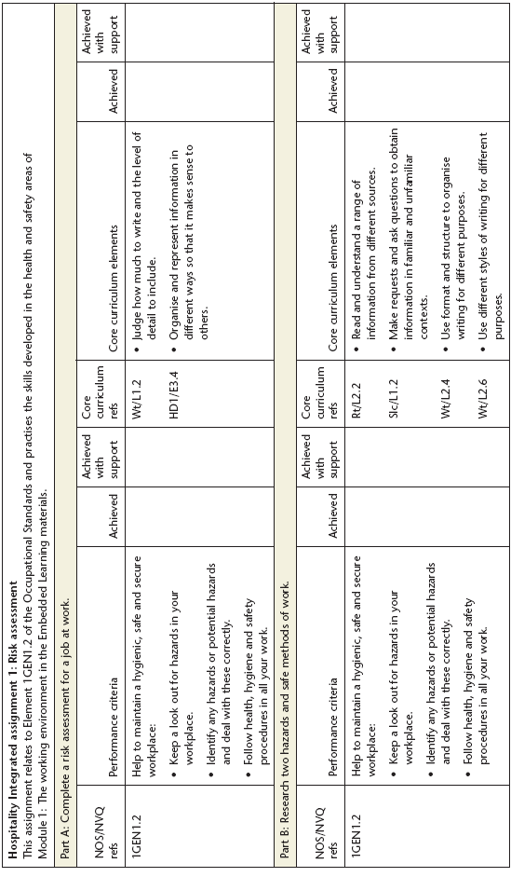
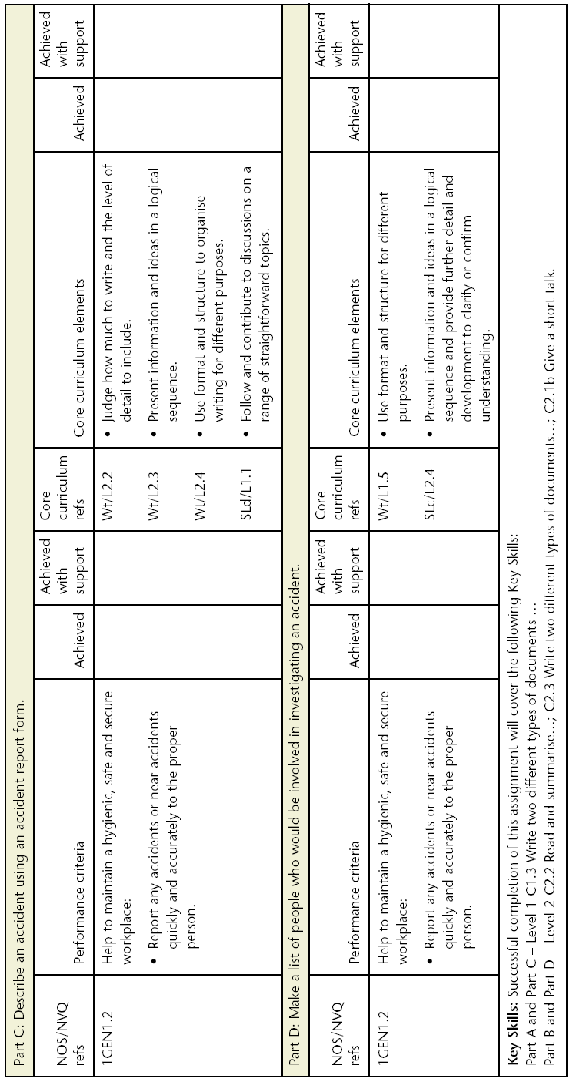
Integrated assignment 2
Customer service

Customer service is very important in hospitality. Good customer service can be the one thing that makes a customer return again and again. Good customer service depends on a range of good communication skills in order to recognise and respond to customers’ needs.

In this assignment you will collect important information from customers to pass on to your supervisor in order to help improve the service provided. You will need to complete Parts A–D:

- Read and make notes on customer service guidelines.
- Make a customer questionnaire from the guidelines.
- Use the questionnaire to ask customers questions.
- Present customers’ answers in an interesting and useful way.

PART A

  - Find the customer service guidelines in your staff handbook or the induction materials you have been given at work.
  - Make a note of the main points, which may cover such things as:
- staff appearance such as what to wear
- restaurant appearance – clean, tidy and well presented
- meeting and greeting customers when they come in
- recognising customers’ needs
- serving customers
If you have any problems with this task you can look at the embedded paper-based materials ‘Finding the information you need’ and ‘The staff handbook’ in Module 1:
The working environment
- being polite
- giving prompt service
- knowing the menu and being able to advise customers
- dealing with problems or complaints.

PART B

Use your notes to write questions you can ask customers to find out what they think of the service.

Choose questions that will tell you what customers think about:
- the way staff look and speak to them
- how helpful staff are
Write your questions in clear and polite language.
- areas that could be improved.

You should ask at least six questions, but you can ask more if you want to.
The examples below show different ways you could write your questions and record the answers. You might use one or more of these styles or you can use your own ideas.
Example questionnaire style 1

1 Do you find staff in this restaurant friendly?
Yes ✓ No __ Don’t know __
Example questionnaire style 2

1 What score out of 5 would you give this restaurant for the way the food is displayed?
1 2 3 4 5
Example questionnaire style 3

- Is there anything you would like to see improved or included in our service?

Quicker service during lunch periods.

More choice for vegetarians
Tick boxes are a quick way to note answers but it means you can only ask simple questions that do not require detailed answers.
A scoring system of 1–5 gives customers a wider range of answers. You can circle the number for speed. You will need to be able to explain the system to customers.
Writing in the answers takes longer but you will get more information. Keep notes short – but make sure you can read them!
Note
- For the three questionnaire styles above consider:
- how easy it will be to ask the questions
- how easy it will be to report the answers in part D
- how much information the answers are likely to give.
- Consider the questions you want to ask and choose the style that will give you the best answer to each question.
If you have any problems with this task, ask your supervisor for advice.
PART C

You can now use your questionnaire to ask customers questions about the service.
You need to speak to at least 20 customers in order to get a good range of people that use your restaurant.
Be polite at all times.

You might also consider asking a mix of the following customers:
- male and female customers
- different age groups
- regular and new customers (you may need to check this).

PART D

Present customers’ answers in a way that will be interesting and useful to your colleagues.
You can:

- write it as a short report using the questions as subheadings and summarising the answers
- make an information leaflet that explains the results of the questionnaire
- make a poster of ‘good’ and ‘bad’ points about the service according to customers
- explain what you found out to your supervisor and make suggestions for what you think could be done to make improvements.
Note
You need permission from your supervisor or manager before you do this.
Note
Think of the best way to use the information you have gathered in order to raise awareness of customer service in your workplace.
- You can make a leaflet or poster more interesting by using bright colours and adding pictures or photographs.
- You could type up your information on computer and use some of the graphics.
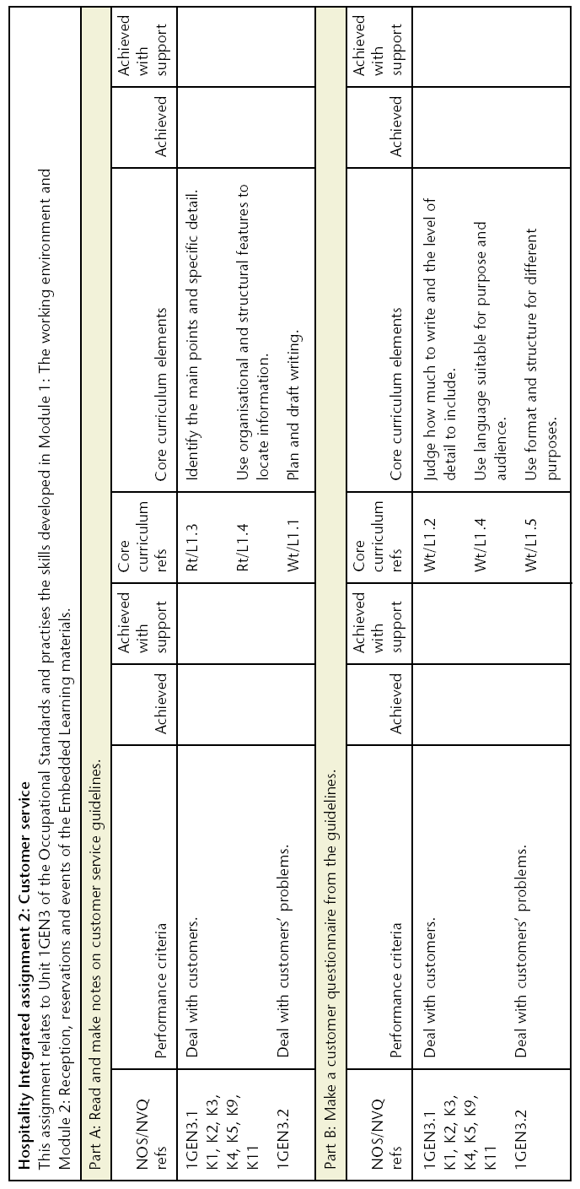
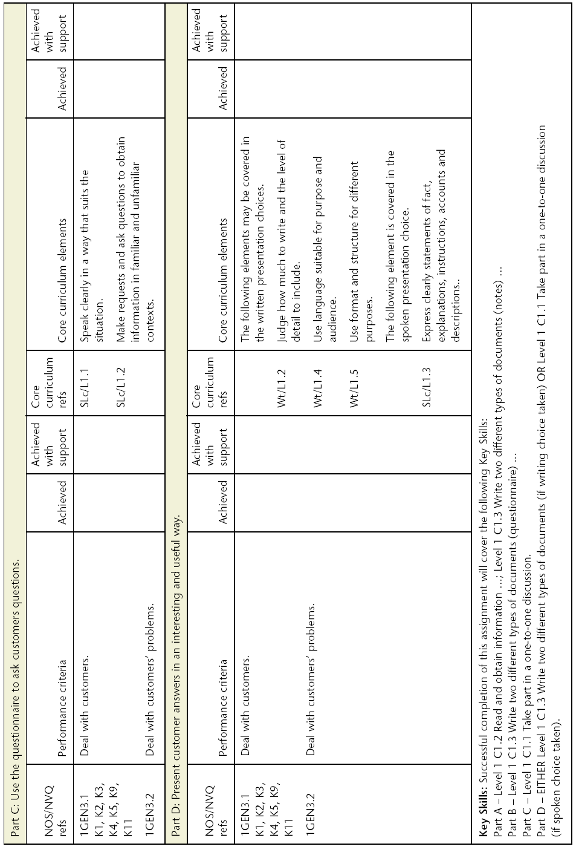
Mapping information for Integrated assignments 1 and 2
Adult Core Curriculum | Key Skills | National Occupational Standards/NVQ
SLc/L1.1, SLc/L1.2, SLc/L1.3  SLd/L1.1  SLc/L2.4  Rt/L1.3, Rt/L1.4  Rt/L2.2  Wt/L1.1, Wt/L1.2, Wt/L1.4  Wt/L1.5  Wt/L2.2, Wt/L2.3, Wt/L2.4  Wt/L2.6  HD1/E3.4 | C1.1, C1.2, C1.3  C2.1, C2.2, C2.3 | Unit 1GEN1 Maintain a safe, hygienic and secure working environment  Unit 1GEN3 Maintain customer care

Source material

Contents

Contents page from the staff handbook (1:1–1:2) 0:01

Organisation chart (1:1–1:2) 0:02

Conference function sheet – Conglemere Hotel (1:1–1:2) 0:03

Lunch menu extract (1:1–1:2) 0:04

Daily rota (1:1–1:2) 0:05

Health and Safety Law poster (1:5–1:6) 0:06

Job description (1:9–1:10) 0:07

Contract of employment (1:9–1:10) 0:08

Sick pay scheme (1:11–1:12) 0:09

Spot the dangers (1:13–1:14) 0:10

General health and safety policy and procedures for Reception (1:13–1:14) 0:11

Guidelines for dealing with bomb threats (1:15–1:16) 0:12

Bomb threat action card – side A (1:15–1:16) 0:13

Bomb threat action card – side B (1:15–1:16) 0:14

Accident report form (1:17–1:18) 0:15

Ground floor plan (1:19–1:20) 0:16

Fire extinguisher labels and instructions (1:21–1:22) 0:17

Reception photograph (2:1–2:2) 0:18
Role-play cards – asking for and giving information (2:3–2:4) 0:19

Procedures for check-in and check-out (2:3–2:4) 0:20

Role-play cards – dealing with complaints (2:5–2:6) 0:21

Reservation form – blank (2:15–2:16) 0:22

Reservation form – completed (2:15–2:16) 0:23

Reservation form – partly completed (2:15–2:16) 0:24

Extract from the staff handbook (2:17–2:18) 0:25

Keeping up-to-date checklist (2:17–2:18) 0:26

Room set-up for the Lowry Suite (2:19–2:20) 0:27

Conference function sheet – Dellamere Hotel (2:21–2:22) 0:28

Web page 1 (3:5–3:6) 0:29

Web page 2 (3:5–3:6) 0:30

Dellamere Restaurant menu (3:5–3:6; 3:7–3:8) 0:31

Food order sheets – blank (3:7–3:8) 0:32

Food order sheet – completed (3:7–3:8) 0:33

Food order sheet – partly completed (3:7–3:8) 0:33

Food hygiene regulations (4:7–4:8) 0:34–0:35

Quo-burgers label (4:9–4:10) 0:36

Hazard analysis flow chart (4:15–4:16) 0:37

Hazard analysis critical control points (4:15–4:16) 0:38–0:39

Pest identification chart (4:15–4:16) 0:40–0:41
Contents page from the 0:01
staff handbook
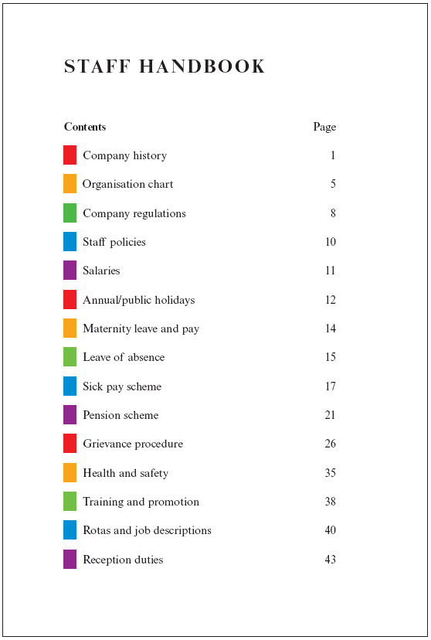
Organisation chart 0:02
General manager
Deputy manager
Head housekeeper
Head chef
Sales manager
Restaurant manager
Conference & events operations manager
House supervisor
Sous chef
Sales coordinator
Restaurant supervisor
Conference & events supervisor
Room attendants Cleaners
Chef de partie
Breakfast
cooks
Waiter/ Waitress
Porters waiting on
Commis Chef
Kitchen porters
Conference function sheet 0:03
CONGLEMERE HOTEL
CONFERENCE FUNCTION SHEET
TITLE: Land Services Ltd  TYPE: Meeting  ORGANISER: Calista Mohanna  HOTEL CONTACT: Martin Parry | EVENT DATE: Friday 22nd May  VENUE: Salisbury Suite  ACCOUNT: Land Services Ltd  DEPOSIT: 100% deposit in advance
Room layout  Boardroom x 12  Tea & coffee buffet  Audio visual  Equipment required:  Pens and paper  Menu  See attached menu | Additional information  Ramp required for disabled guests  Billing information  Numbers: 12 pax  Minimum no: 10 pax  Final numbers by: Monday 18th May  Charges:  Room hire @ Ł350.00 plus VAT  Tea, coffee and biscuits  @ Ł3.50 per person  Beverages on consumption  Working lunch buffet sandwiches  @ Ł4.50 per person

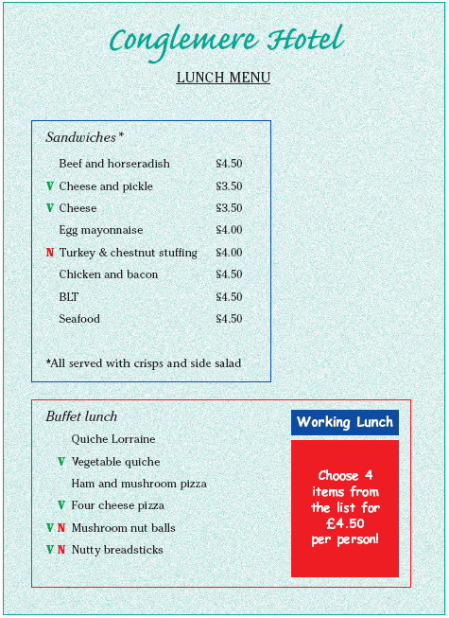
Lunch menu extract 0:04
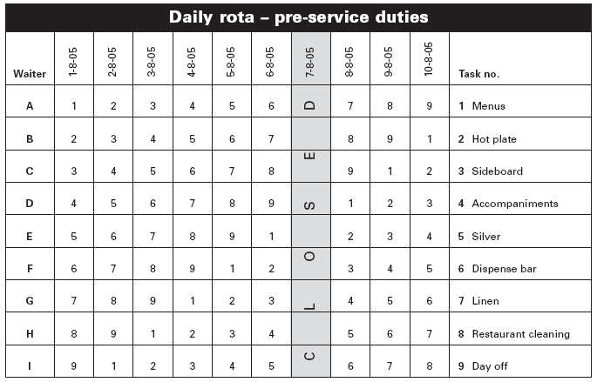
Daily rota 0:05
Health and Safety Law poster 0:06

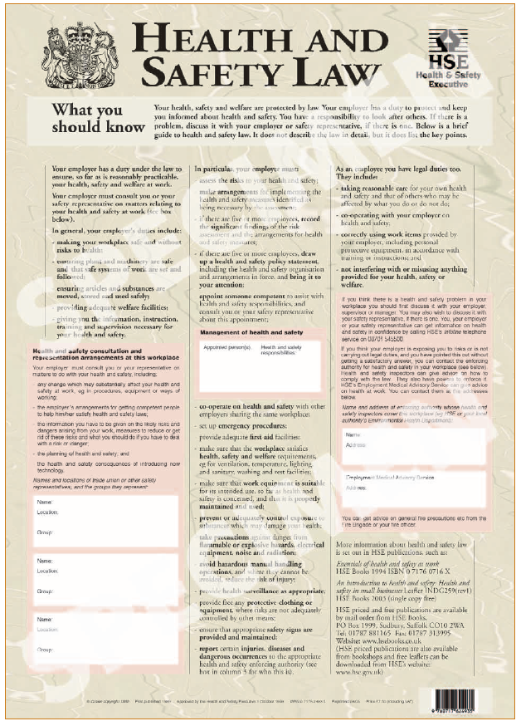
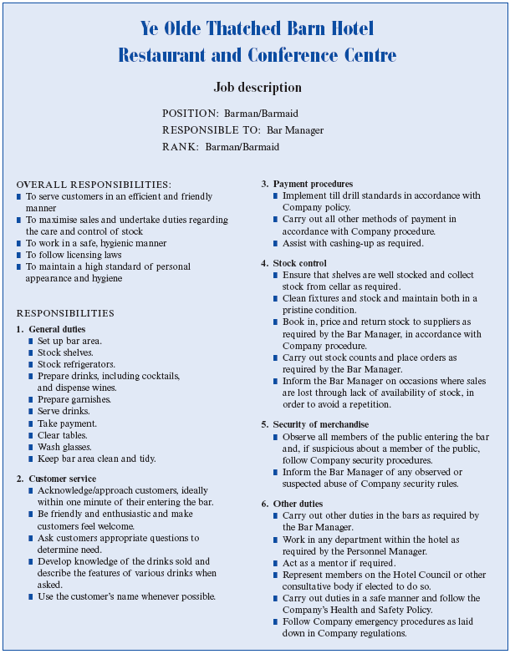
Job description 0:07
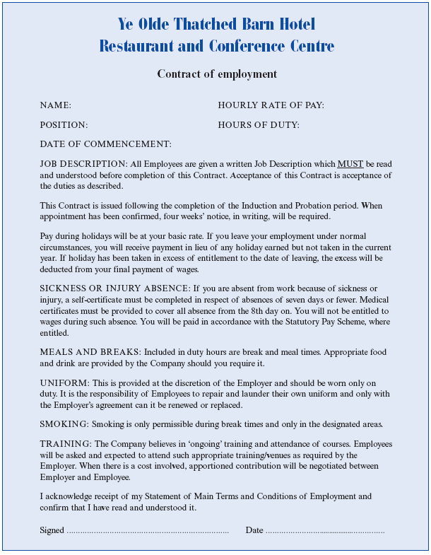
Contract of employment 0:08
Sick pay scheme 0:09
The Chain hotels sick pay scheme applies to all permanent employees.
The sick pay year commences on 1 April. Payment during absence due to illness is made subject to the limits of the following scale during the sick pay year. In applying the scale, absence during the year is aggregated.

Period of continuous employment as at the start of the sick pay year (i.e. 1st April) or on completion of 6 months’ service for those with less than 1 year’s service.
Period of full pay

Less than 6 months Nil
6 months but less than 1 year 4 weeks
1 year but less than 2 years 6 weeks
2 years but less than 3 years 10 weeks
3 years but less than 4 years 14 weeks
4 years but less than 5 years 17 weeks
5 years but less than 10 years 20 weeks
Over 10 years 26 weeks

If the rules regarding notification of sickness have been observed, payment during certified absence because of genuine illness or injury will normally be made, subject to the following limitations. Payment, however, is at the discretion of the Company.

Chain hotels reserves the right, when considered appropriate, not to make payment when:
- Absence results from an accident/injury which occurs outside the course of employment. If the payment is made and you are subsequently able to claim the costs from the responsible party or an insurance policy, then these are to be repaid to the Company.
- You fail to follow the absence reporting procedure.
- There is reason to doubt the validity of your absence.
- The illness or injury was self-inflicted.

Absence which commences in one sick pay year and continues into the next is deemed to be absence during the first year for the purpose of calculating sick pay entitlement, and payment will continue until entitlement is exhausted. Any further entitlement to payment during illness in the second year is dependent upon you returning to work in the second sick pay year for a minimum of 4 consecutive working weeks.
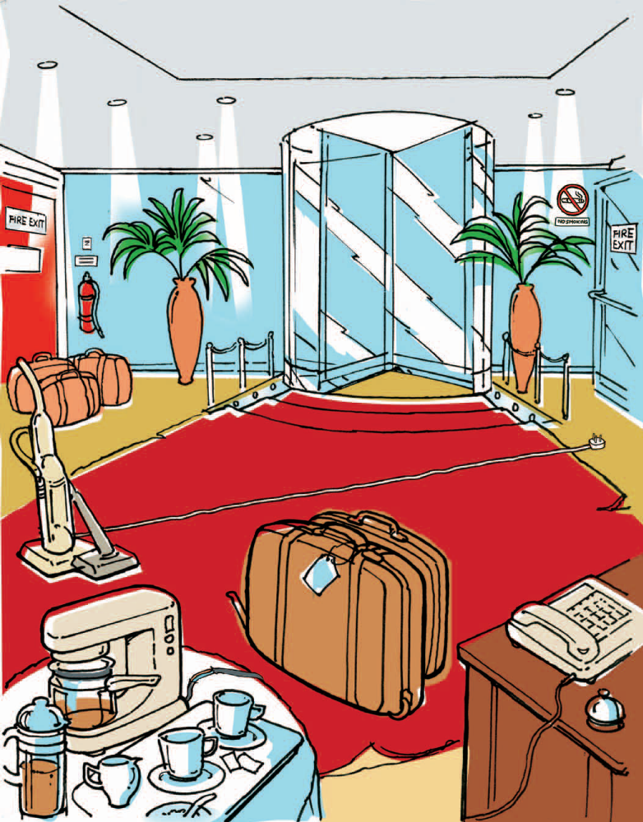
Spot the dangers 0:10
General health and safety policy 0:11
and procedures for Reception
General health and safety policy and procedures for Reception

Employees should take reasonable care of themselves, other employees and other persons on the premises. This means looking out for hazards and taking action to prevent injuries.

General hazards
- Trips, slips and falls
These are the most common accidents and are caused by slippery surfaces, obstructions left on or across the floor, or uneven floor surfaces such as missing floor tiles, worn patches of carpet or floor coverings that have come unfixed.

Prevention/procedure: Staff should be vigilant in noticing any of these hazards. Moveable trip obstructions such as cables should be removed immediately and the situation reported to the supervisor. The obstacle or item should be put in a safe place out of the way. Fixed items such as carpets or floor defects should be isolated using a free-standing warning sign and be reported to the Maintenance department. Newly polished or wet floors following cleaning should have a free-standing warning sign. Any spillages should be reported and a warning sign put up to stop people from treading in the spillage.

- Walking into objects
This might involve fixed objects such as pillars and doors or moveable objects such as plants and furniture.
Prevention/procedure: Warning signs are needed on fixed objects if incidents occur regularly. Moveable objects should be put in a place where they are clearly
visible or out of the way. Avoid crowded conditions.

- Electric shock
This is often caused by faulty or damaged equipment.
Prevention/procedure: Machines should be tested regularly and plugs checked for damaged flexes, exposed wires or damage to the plug itself. Switches and light fittings should also be checked. If damage is found, machines should be switched off immediately and an ‘out of order’ sign put on them. Any damage should be reported to the Maintenance department and to the supervisor immediately.

- Fire risks
These can be electrical or caused by discarded cigarettes or matches. Staff should be aware of the fire drill and positions of fire exits and fire points. Training will be given on fire safety, including fire fighting equipment and procedures. (There is an annual check of fire equipment such as extinguishers.)
Prevention/procedure: Staff should be vigilant for any sign of fire and make sure fire exits are clear of obstructions at all times, without exception. Any obstruction of fire exit should be cleared and the situation reported to the supervisor, who will keep account of these instances for safety meetings.
Guidelines for dealing with 0:12
bomb threats
8 Bomb threats

8:1 What is a bomb threat?
A bomb threat is a warning that a bomb may explode in or near the premises. The threat may be made by telephone or a bomb may be thrown or deposited by hand.

8:2 Arrangements and responsibilities

8:2 i Manager’s responsibilities
- Instruct employees to take the correct action in the event of a bomb threat.
- Ensure regular warnings and testing of procedures are carried out.
- Display notices near a telephone with action points about what to do.
- Ensure good housekeeping and lock unused areas.
- Inform the police and senior manager if suspicious about any unusual objects.

8:2 ii Employees’ responsibilities
- Know what to do in the event of a bomb threat.
- Be familiar with the escape routes and evacuation procedures.
- Always be vigilant.
- Inform manager if suspicious about any unusual unattended packages.

8:3 Key safety points

8:3 i Know what to do in the event of a bomb threat
- Keep calm.
- Try to obtain as much information as possible.
- Call the police.
- Evacuate the building.
- Inform the senior manager as soon as possible.

8:3 ii On discovery of a suspicious package
- Do not touch it or attempt to move it.
- Evacuate the premises, including any toilets.
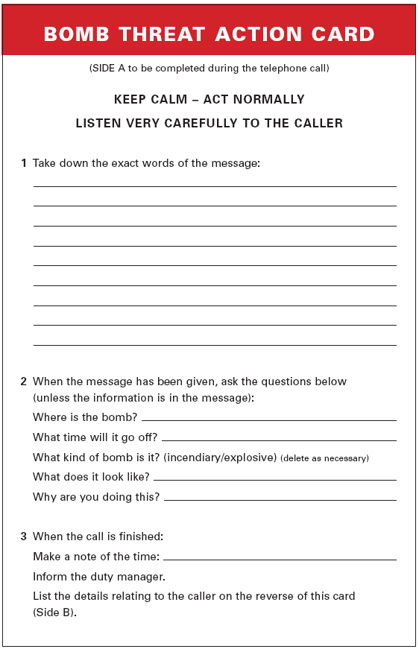
Bomb threat action card – side A 0:13
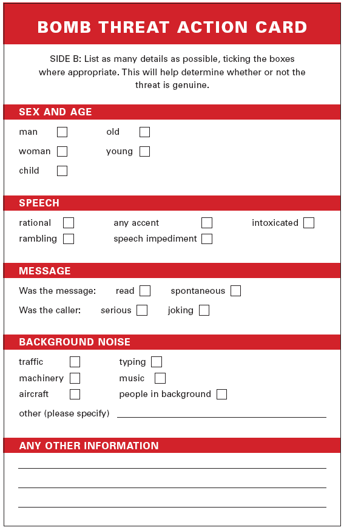
Bomb threat action card – side B 0:14
Accident report form 0:15

ACCIDENT REPORT

1. About the person who had the accident
Name _______________________________________________
Address _____________________________________________
____________________________________________________
______________________________ Postcode ______________
Occupation ___________________________________________

2. About the person filling in this report
Fill this in only if you are not the person who had the accident.
Name _______________________________________________
Address _____________________________________________
______________________________ Postcode ______________
Occupation ___________________________________________

3. About the accident
Say when it happened.
Date __________________________ Time _________________
Say where it happened. _________________________________
Describe how it happened and any injury caused.
____________________________________________________
____________________________________________________
____________________________________________________
Sign and date the record
Signature ____________________________________________
Date ________________________________________________

4. For the employer only
Complete this box if the accident is reportable under RIDDOR.
How was it reported? ___________________________________
Date reported _________________________________________
Signature ____________________________________________

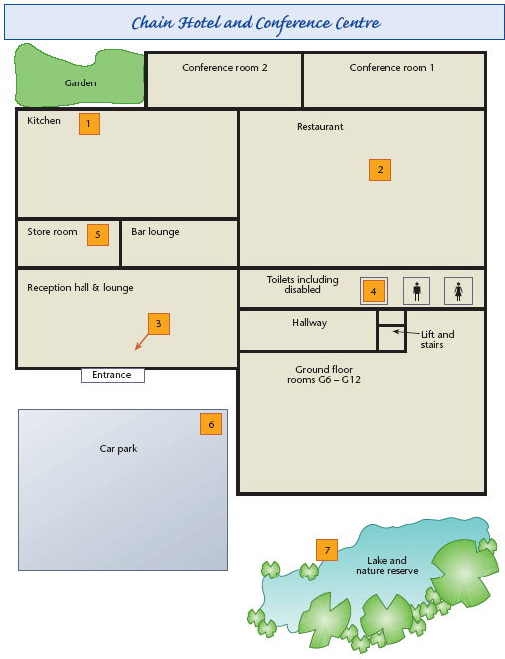
Ground floor plan 0:16
Fire extinguisher labels and 0:17
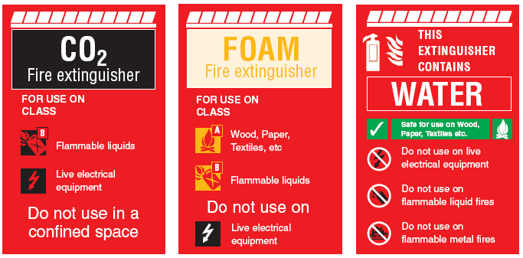
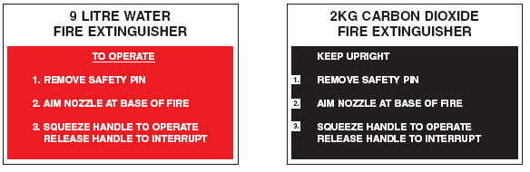
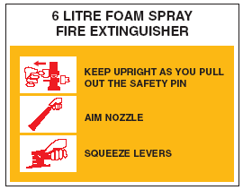
instructions
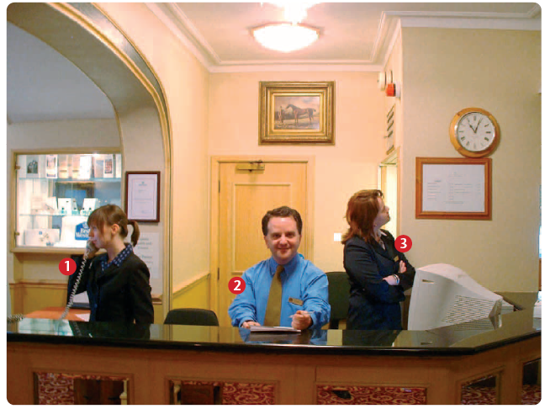
Reception photograph 0:18
Role-play cards – asking for and 0:19
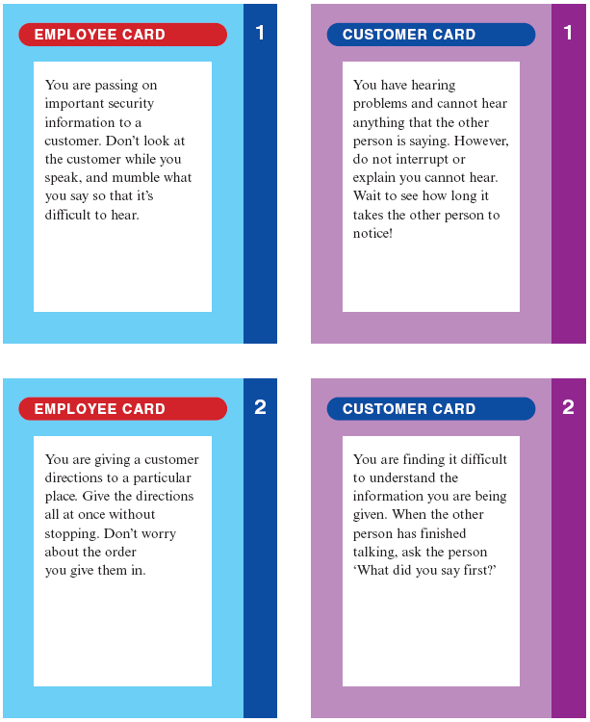
giving information
Procedures for check-in 0:20
and check-out
Procedures for check-in – new guests
- Smile and make eye contact with the guest. Say good morning, afternoon or evening.
- Ask for the guest’s surname and initials.
- Find the guest’s details on the system and confirm the address.
- Present the registration card and ask the guest to check the details and sign the card.
- Ask whether the guest requires a smoking or non-smoking room.
- Confirm the reservation details to the guest:
- Room type
Procedures for check-out
- Once a guest has told you she or he wants to check out, confirm the guest’s name or ask for the guest’s name if you do not know it.
- Find the guest’s information on the system and confirm the guest’s name and room number.
- Print out an invoice for the guest and ask the guest to check that it’s correct.
- Ask the guest how he or she will be settling his or her account.
- While the account is being settled, check that the guest enjoyed their stay.
- When the account is settled, thank the guest for staying and offer a hotel brochure for future reference.
Role-play cards – dealing with 0:21
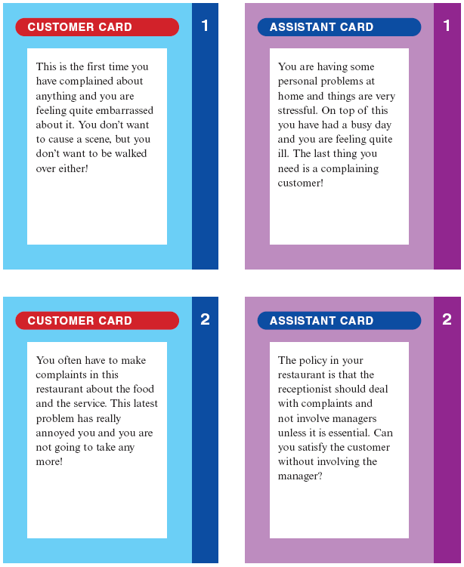
complaints
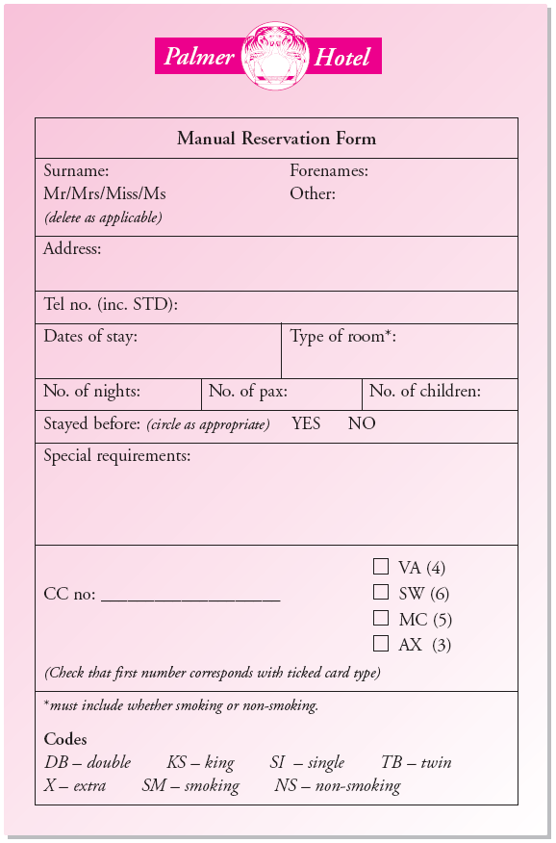
Reservation form – blank 0:22
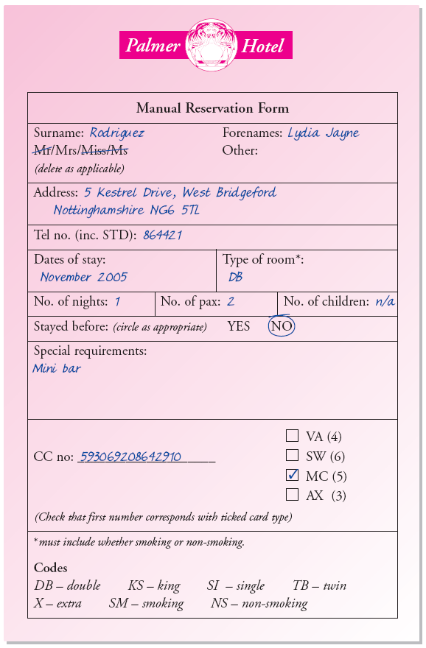
Reservation form – completed 0:23
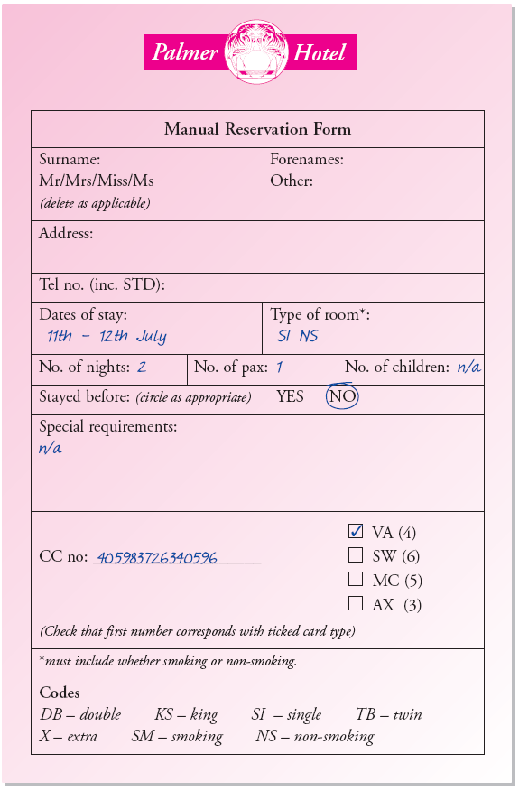
Reservation form – partly completed 0:24
Extract from the staff 0:25
handbook
9 Advising customers Customer Service

Hotel selling points
Guests will ask about prices and special rates the hotel offers. Many will also want to know what facilities the hotel offers, including rooms, leisure facilities, dining options, facilities for the disabled, special events and services.
Give information positively so that it gives a good impression of the accommodation and services provided.

Function room information
For function room enquiries you will need to know the capacity of pax for each room. Similarly, in order to give the correct information, you need to know how many covers can be seated comfortably in the eating area of the different conference rooms.

Timetables
Travel timetables contain useful information for you to give to guests.
If a guest needs to catch a train, ring up to doublecheck the times, cost and any delays.

Maps
Maps can help you to give guests clear directions for how to get to the hotel and local tourist areas.
Customer Service Advising customers 10

Local attractions/events
Guests and potential guests may want to know about local attractions, such as fairs, historical places, shopping complexes or theme parks. There will also be events taking place in the area at different times of year. You may be required to give directions to these places and know some details about them (see below).

How to find information
There is plenty of information to be found in the hotel, for example, in staff handbooks, brochures, guest information and so on. Senior members of staff will advise you on any special information you need to know about. The brochure information will be kept up-to-date, so this gives you the opportunity to update your own knowledge.
- Knowing what the guests know is important, so make sure you read all the information given to guests on arrival.
- Stay overnight in the hotel in order that you have experience of the product you are selling.
- Visit local attractions and make a note of the most suitable places and the cost for single people, families, elderly and disabled people.
- Find out about what our competitors are offering, for example, their rates, services and facilities.
Keeping up-to-date checklist 0:26
Keeping up-to-date | ✓
Reading information
Staff handbooks – finding out about regular services
Staff newsletters or bulletins – finding out about new services and special promotions
Information booklets or leaflets – leaflets or booklets sent to customers or displayed in reception areas
Promotion materials – customer information and advertising information from own company and competitors
Brochures advertising services
Internet sites – giving detailed information about competitors
Listening to information
Updating services training sessions
Customer feedback
Other staff members
Market research – ringing up competitors or customers and asking questions about the type or standard of service
Gaining first-hand experience
Trying out the services or products in your own place of work – for example, by spending a night in the hotel, or having a meal in the restaurant
Trying out services in other hotels and restaurants in your area
Visiting local tourist attractions

Room set-up plan for the 0:27
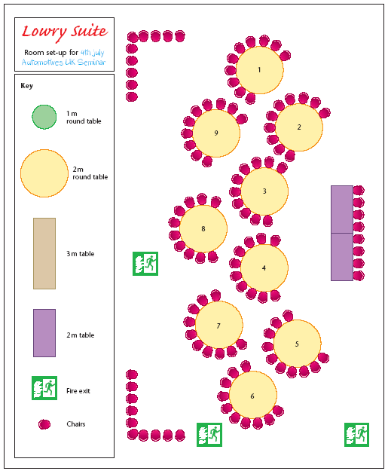
Lowry Suite
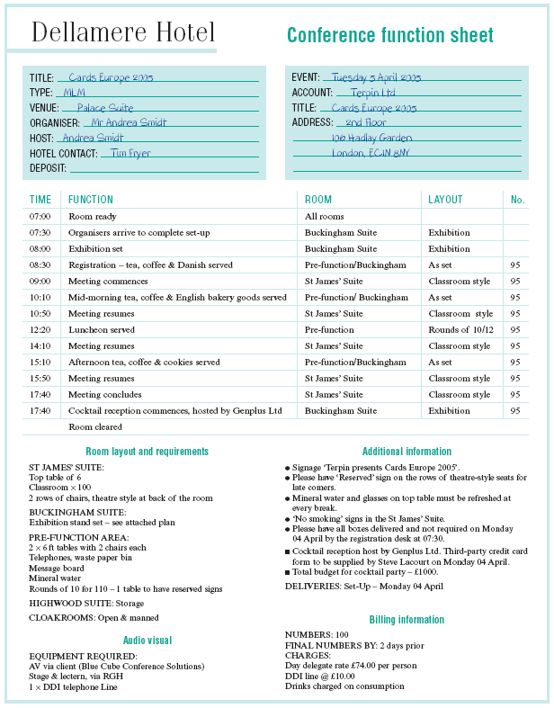
Conference function sheet 0:28
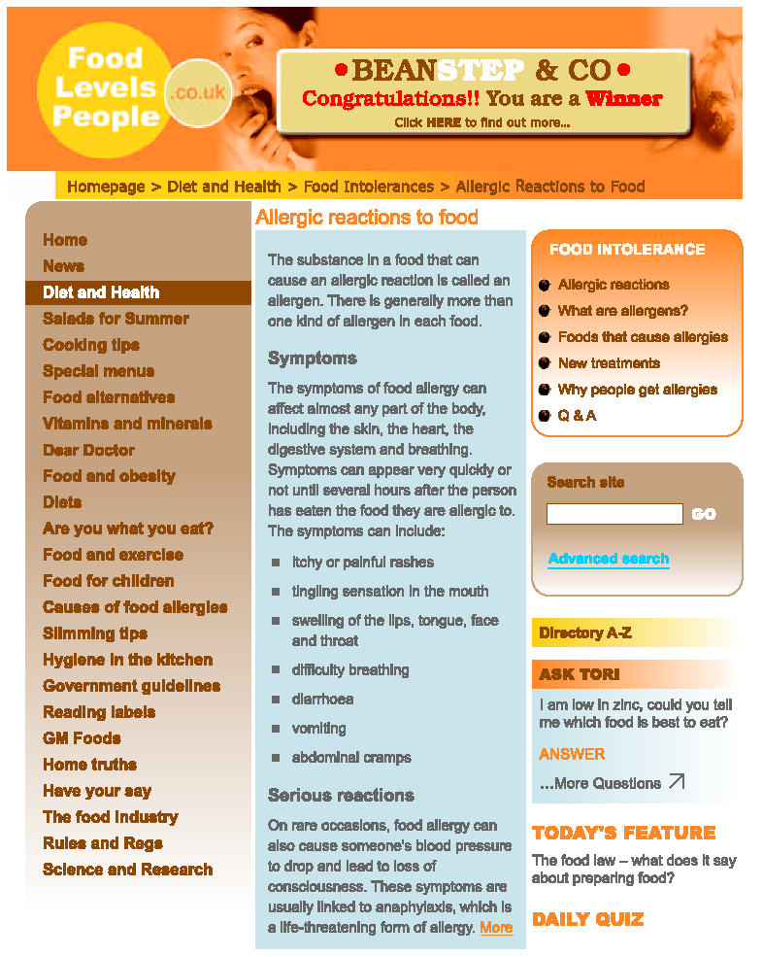
Web page 1 0:29
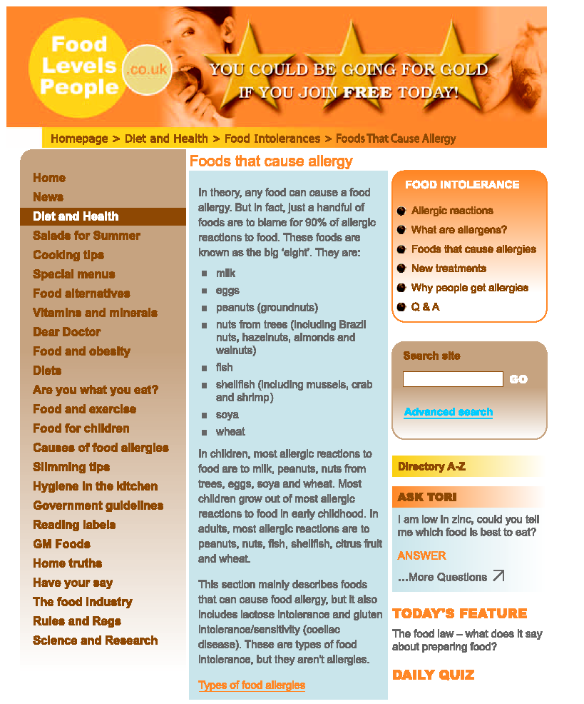
Web page 2 0:30
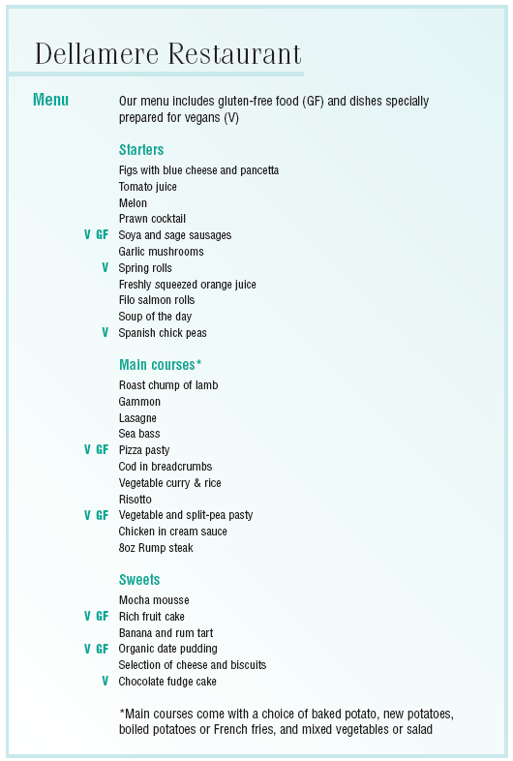
Dellamere Restaurant menu 0:31
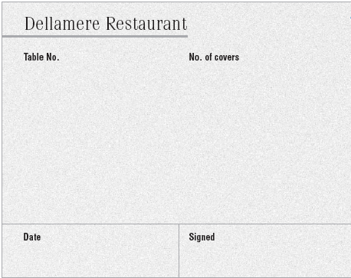
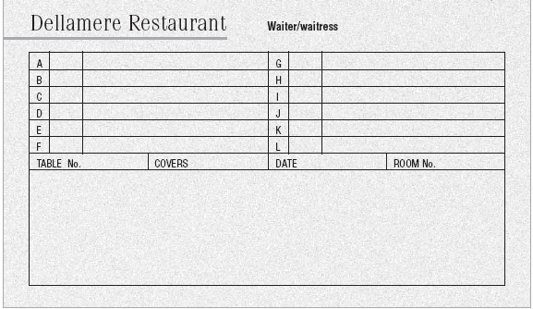
Food order sheets – blank 0:32
Example 1
Example 2
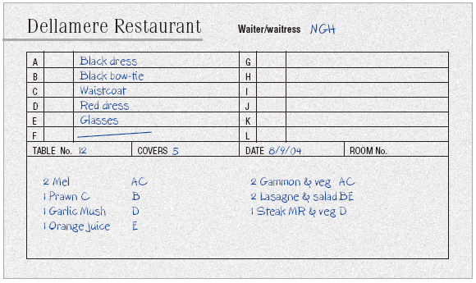
Food order sheet – completed 0:33

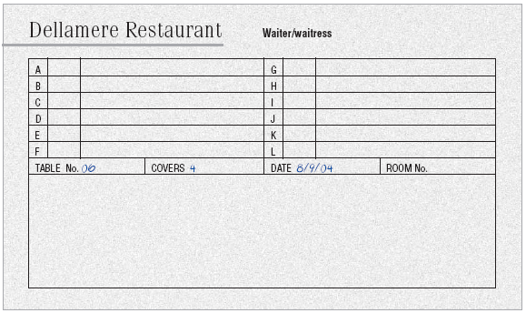
Food order sheet – partly completed
Food hygiene regulations 0:34
The Food Safety (General Food Hygiene)
Regulations 1995

Made 12th July 1995
Laid before Parliament 12th July 1995
Coming into force 15th September 1995

ARRANGEMENT OF REGULATIONS

- Citation and commencement
- Interpretation
- Application of provisions of these Regulations
- Obligations upon proprietors of food businesses
- Persons suffering from certain medical conditions
- Offences and penalties
- Application of provisions of the Act
- Enforcement and execution
- Amendments of other Regulations
- Revocations

SCHEDULES
- Rules of hygiene
Chapter I General requirements for food premises
Chapter II Specific requirements in room where foodstuffs are prepared, treated or processed
Chapter III Requirements for movable and/or temporary premises
Chapter IV Transport
Chapter V Equipment requirements
Chapter VI Food waste
Chapter VII Water supply
Chapter VIII Personal hygiene
Chapter IX Provisions applicable to foodstuffs
Chapter X Training
- Amendments to other Regulations
- Revocations
0:35
Statutory Instrument 1995 No. 1763
The Food Safety (General Food Hygiene) Regulations 1995

SCHEDULE 1
Regulation 4(2)

RULES OF HYGIENE
Chapter I

General requirements for food premises (other than those specified in Chapter III)

- Food premises must be kept clean and maintained in good repair and condition.
- The layout, design, construction and size of food premises shall:
- permit adequate cleaning and/or disinfection;
- be such as to protect against the accumulation of dirt, contact with toxic materials, the shedding of particles into food and the formation of condensation or undesirable mould on surfaces;
- permit good food hygiene practices, including protection against cross-contamination between and during operations, by foodstuffs, equipment, materials, water, air supply or personnel and external sources of contamination such as pests; and
- provide, where necessary, suitable temperature conditions for hygienic processing and storage of products.
- An adequate number of washbasins must be available, suitably located and designated for cleaning hands. An adequate number of flush lavatories must be available and connected to an effective drainage system. Lavatories must not lead directly into rooms in which food is handled.
- Washbasins for cleaning hands must be provided with hot and cold (or appropriately mixed) running water, materials for cleaning hands and for hygienic drying. Where necessary, the provisions for washing food must be separate from the hand-washing facility.
- There must be suitable and sufficient means of natural or mechanical ventilation. Mechanical air flow from a contaminated area to a clean area must be avoided. Ventilation systems must be so constructed as to enable filters and other parts requiring cleaning or replacements to be readily accessible.
- All sanitary conveniences within premises shall be provided with adequate natural or mechanical ventilation.
- Food premises must have adequate natural and/or artificial lighting.
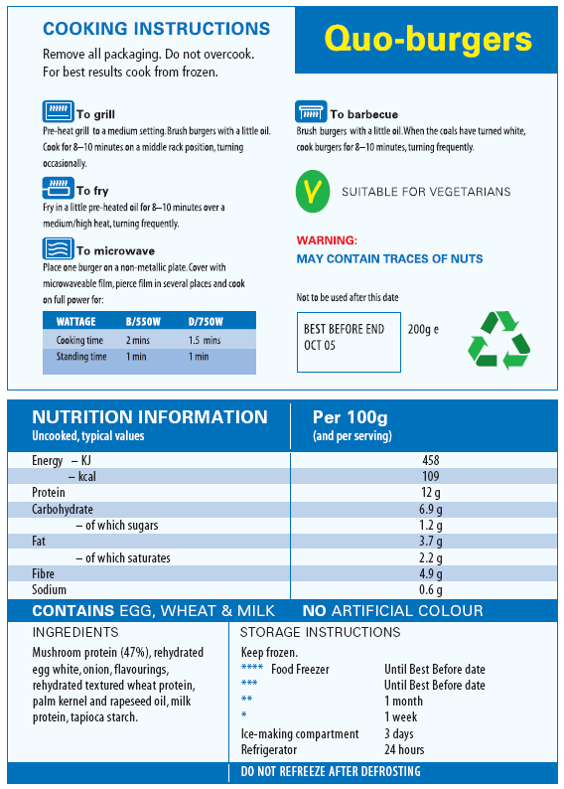
Quo-burgers label 0:36
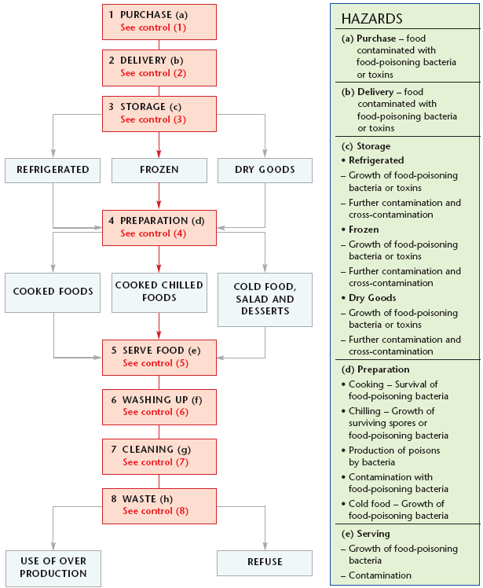
Hazard analysis flow chart 0:37
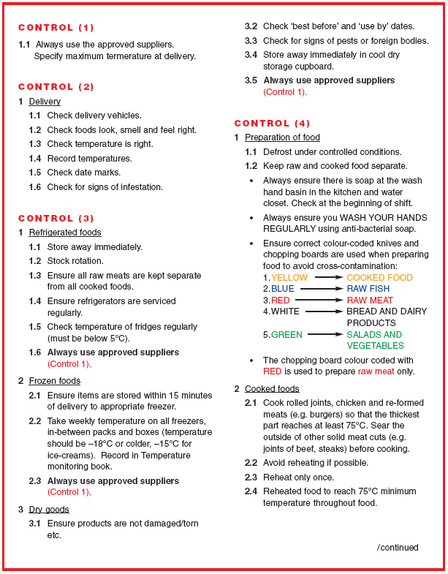
Hazard analysis critical control points 0:38
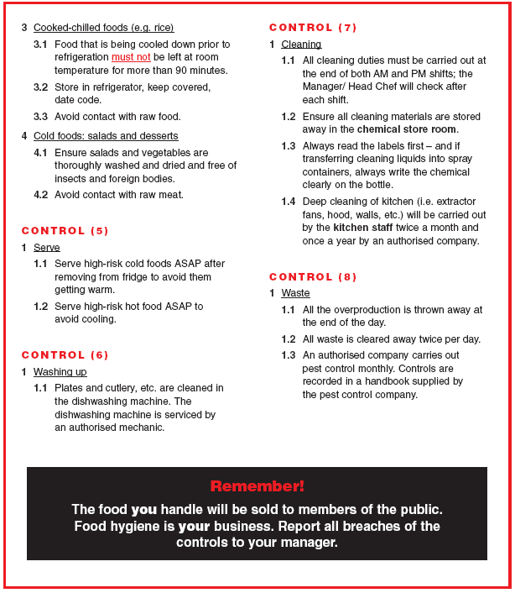
0:39
Pest identification chart 0:40
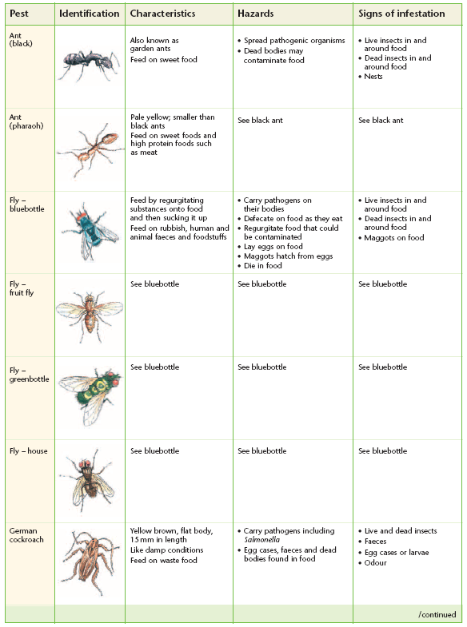
0:41
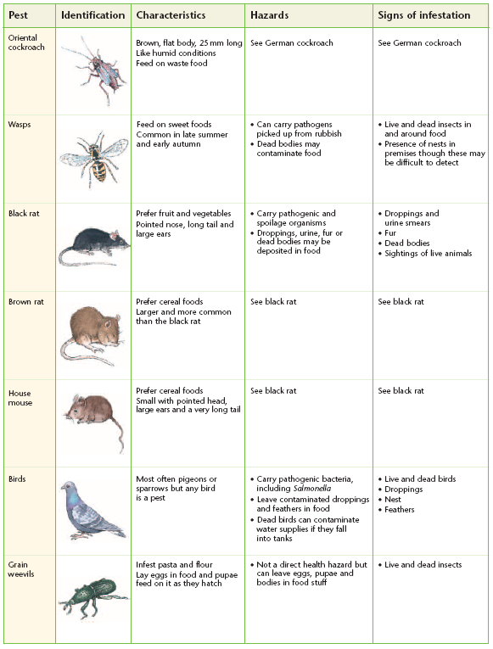
Glossary

abbreviate cut short or reduce
abbreviation(s) shortened forms of written words (e.g. on a form ‘Tel’ is often written instead of ‘telephone’, ‘DOB’ instead of ‘date of birth’)
abdominal to do with the abdomen or belly
acceptance agreement with
accompaniments things that go with particular meals – mint sauce, horseradish, etc.
accordion folds material or paper folded under then over several times to make an accordion shape
acknowledge greet, welcome
Act piece of legislation, statute, part of the law
additive preservative, stabiliser, chemical ingredient added to food
aggregated combined, added up
allergy (plural: allergies) sensitivity or reactions to certain things (e.g. a hay fever sufferer has an allergy to pollen)
amend make changes, alter, revise
analysis investigation, breaking down into small steps
applicable applies to, is relevant to
application how something should be used
appropriate suitable for the situation, correct
arthritis disease causing painful swelling and stiffness of the joints
as per in accordance with (e.g. ‘give guidance as per customer requirements’)
assess consider, weigh up performance
assessment a review or check to make sure you can do something
assist help
attentive paying attention, thoughtful
audit a stock take
authorisation permission from someone in charge
bacteria one-celled organisms, some of which cause disease
bactericide a substance used to destroy bacteria
beverages drinks
bias favouring one side of an argument for personal reasons
biocide a substance used to kill living organisms
biological to do with living things (e.g. a biological hazard might be bacteria or rats)
borne carried (e.g. air-borne disease is disease carried by air)
brackets punctuation used in writing at either end of some extra information in a phrase or sentence
bye-law (by law) local law made by a local authority; it is applicable only in the area in which it is made
cabaret style arrangement of tables with chairs facing a stage or top table
café style arrangement of tables with chairs set around the table
canteen dining hall, cafeteria
capacity the maximum number of people a room can hold
carbon dioxide a gas used in some fire extinguishers
category group
Celsius a scale of temperature in which water freezes at 0 degrees and boils at 100 degrees (the same scale as centigrade); named after a Swedish astronomer called Anders Celsius
centigrade a scale of 100 degrees (the same scale as Celsius)
chargrilled grilled quickly at a very high heat over charcoal
chemical to do with chemicals (e.g. chemical hazards might be cleaning materials or fly sprays that accidentally contaminate food)
cheque guarantee card a plastic card issued by your bank to go with your cheque book
chump thick end of a loin
citation quote, the way the Act should be referred to
clasp hold on to, grip
clinical thermometer a thermometer used to measure body temperature
code of practice an explanation of how a law should be enforced; recommended standards
commencement beginning
commensurate in proportion; corresponding in size or amount
compensate to make up for something
competence skill, ability
competitors rival companies
condiments salt, pepper, etc.
confidential private and secret
confined small, enclosed
confined space small, enclosed space with not many windows and doors
consecutive numbers numbers that follow on (e.g. 6, 7 and 8 are consecutive numbers)
consistently time after time, reliably
consumption the act of eating or drinking
contaminant something that contaminates
contaminated infected, made dirty
contamination when unwanted items or bacteria are present
Contract of Employment legal document with the details of your job, holidays, pensions, etc.
contracted caught or developed (a disease)
converting changing or adapting
corresponds (with) matches
covers i ‘guests’
ii place settings for a specific dish or meal
credit card a plastic card that allows you to make purchases immediately and pay for them later
Critical Control Point (CCP) the step in the preparation of food that has to be carried out correctly to make sure that a hazard is removed or reduced to a safe level
cross-contamination when micro-organisms are moved from one place to another on a vehicle of contamination (e.g. hands)
cruets small containers for things like salt, pepper, vinegar or oil
currency money
custody looking after or being in charge of something
dash short horizontal mark used like a bullet point
debit card a plastic card where the money you spend is taken directly out of your account
deduct subtract, take away from
defecate discharge faeces from the body
degree a unit of measurement of temperature
delegate a representative sent to a conference
delete cross through or out
demonstrated shown, proven
determine decide
diagonally on an angle
direct straight
directive instruction, order, command (e.g. European Directive – an instruction from the European Union to a member state to tell them to introduce new laws or change their old ones)
disciplinary procedure action that takes place when rules have not been obeyed
discretion judgement, opinion
disposable throwaway
distinctly clearly
due diligence a defence in law where the accused can show that they have done everything possible to prevent an offence occurring
duties the things you have to do for your job
efficiently in a well-organised and professional way e.g. ‘for example’, from the Latin exempli gratia
EHO Environmental Health Officer
emphasis put stress on a word or phrase to make it stand out
emphasise make a word or phrase stand out as important
employee worker, member of staff
employer a person who employs others or gives work to others
entitlement what you have a right to receive
etc. ‘and the rest’, from the Latin et cetera
evidence facts which show something, proof
external outside
factual based on real life, not made up
faeces waste matter that is left after food has been digested and is discharged from the bowels
Fahrenheit a scale of temperature where water freezes at 32 degrees and boils at 212 degrees; named after German physicist Gabriel Fahrenheit
filo thin flaky pastry
fire extinguisher equipment used to put out or stop a fire
flammable easily burnt
formal polite, according to the rules of society
format the way the text is set out or looks on the page
fungicide a substance used to destroy fungi
genuine real
germicide a substance used to kill germs
gist the general idea of what something is about
goblet type of metal or glass drinking-vessel with a bowl-shaped cup
guide show the correct way to do things
guideline a general rule or piece of advice
hazard a danger or risk
holiday entitlement the holiday time you are allowed
humid hot and damp
hyperlinks words or symbols on a web page from the Internet that you can click on to take you to another page of information
hyphens punctuation marks that join words together or separate phrases in notes
i.e. ‘that is’, from the Latin id est
impediment (speech impediment) anything that makes speech unclear such as a stutter, lisp or stammer
imperative(s) something that is important, something that must be done
in accordance with in agreement with
in lieu in place of
incident an event or happening that could have been dangerous
inclusive included as part of the charge
incubate develop without outward signs (especially a disease)
incubation period the time it takes for a disease to develop
induction the period of introduction to a new job
inhaling breathing in

interlace entwine, link
interlock link, join
interpretation help with understanding something
intolerant unable to tolerate or digest certain foods (e.g. lactose intolerant, not able to digest lactose)
intoxicated drunk
irritated cross, angry or annoyed
italics written in sloped writing
jargon specialist, technical words used by a particular group or profession
job description a document describing the exact tasks in your job
lactose a type of sugar naturally present in milk and milk products
larva (plural: larvae) young insect (e.g. a caterpillar)
layout overall plan, design or arrangement that helps you to tell what something is at a glance
legislation laws
limitations restrictions
line manager member of staff in charge of you and your work
liqueur strong and sweet alcoholic spirit
live electrical equipment machines and equipment that use electricity and are plugged in
location place or position
log record
logical using reason, good sense
logical order in the order that things should be done, not out of sequence
maintain keep up
mandatory compulsory, must be done, required by
law
manual (n) an information pack or book (e.g. an
instruction book)
manual (adj) by hand (e.g. manual work is work done by hand)
market general term for the buying and selling of items or services
maximum the highest or largest amount
micro small
mind map a graphical way to sort and record information
minimum the least or lowest amount
minus negative amount
mise-en-place preparation for service (e.g. getting the bar area ready)
mobile moveable
mocha chocolate and coffee flavouring
multiple many
national all over the country
negative numbers numbers less than zero
non-metallic not made of metal
nutritional relating to health and diet
nutritional values the amount of different types of vitamins, minerals and other types of nourishment in a particular food
obligation something that somebody must do
observation watching, inspection
opinion a personal view or belief, not necessarily a fact
optics devices in the neck of upturned bottles displayed behind a bar that measure out the correct amount of spirit into a glass
optional possible, chosen
organism an individual animal, plant or single celled life form
palm inner surface of the hand between the wrist and the fingers
pancetta cured belly of pork
pasteurised sterilised (e.g. wine, milk, etc.), usually by heating to a particular temperature
pathogenic relating to micro-organisms that cause illness
pathogen(s) very small forms of life that cause illness
pax hospitality term for people, customers or guests
performance the way something is done
personnel staff or workers
pesticide a substance used to kill pests
PFA pre-function area
physical to do with real, touchable things (e.g. physical hazard might be a hair clip or a piece of metal from machinery that falls into food)
plus and, in addition to
podium a small platform on which a person can stand to be seen by an audience
policy a set of guidelines put in place by an organisation to be followed by their workforce
portfolio collection of work, file
positive helpful and encouraging
positive numbers numbers more than zero
prior to before
pristine perfect
pro rata proportional, ratio of one thing to another
procedure particular method or way of doing things
prohibition a type of sign that shows something that is not allowed, something you must not do
promote sell by making something sound attractive
proprietor owner
provision conditions
pupa (plural: pupae) the stage in the life of an insect between larva and adult (e.g. a chrysalis)
qualification proof that a certain level of competence has been achieved

rambling confused
range extent; different situations in which a person may be expected to perform competently
rational sensible, logical
reactive unplanned, in response to something else
recyclable material that can be used again
regulation rule, explanation of the way an act is to be interpreted; can become part of the law
regulo used before a numeral to indicate a setting on a temperature scale in a gas oven
regurgitating bringing swallowed food back up
rehearse practice
relevant needed, appropriate
replenish refill or restock supplies
responsibility a thing you are required to do as part of your job, a legal duty
rights things due to you in law
risk the likelihood that a hazard will occur
rotational turning, round and round
rounds round tables with chairs
salmonella bacterium that occurs mainly in the gut and may cause food poisoning
scan to look quickly through (in this case, a piece of writing to find particular words or phrases)
schedule a list of processes or procedures
signed off signed by your assessor to say that you have completed this section
simulation a pretend situation, something that is like real life
sincere truthful and friendly, not pretending or acting
skim read a piece of text very quickly to get the general idea of what it is about without needing to read every word
slang language used in very informal social situations
source starting place, cause
specific exact
specify state, say
spidergram a way of sorting information using connecting bubbles
spontaneous natural, spur of the moment
spore a small single-celled unit from a plant or fungi that is capable of reproducing asexually; a hard, resistant body formed within the bacterial cell
standard(s) level(s) of competence
statute a law
sterilise clean thoroughly, make germ free
sterling word used to describe British money
strategies ways or approaches for doing something
subject main topic or purpose of a text
subsequently later, afterwards
summarise sum up by giving the main point or points of something
supplementary additional, extra
symbols marks or signs with a particular meaning (e.g. health and safety signs)
symptoms signs of a particular illness (e.g. a rash)
technique method, skill
textiles materials such as cloth or fabric
thawed defrosted, no longer frozen
theatre style chairs in rows
thermometer an instrument used to measure temperature; it can be digital, infra red, traditional
thrive blossom, increase
tone the manner in which something is said (e.g. sadly, in a bored way, excitedly)
tortellini small pasta parcels stuffed with cheese or vegetables
toxin a poison produced by some bacteria and moulds
unauthorised not allowed or given permission
unnecessary not required or important for understanding
unpasteurised not sterilised
unsupported not proved, based on opinion without evidence
valid officially acceptable
vegan person who does not eat or use any animal products
vehicle i a thing used for transporting people or goods on land
ii a means of expressing something
vehicle of contamination an object, person or animal on which micro-organisms can move from one place to another
venue place or room
verification proof, confirmation
via through
vice versa the other way round
vigilant observant, alert, on your guard
vocational to do with particular jobs, occupations and employment

